Themes as we Journey
the Stations of the Cross

- Confession of Sins-Luke 6: 46-49, Luke 7:44-50
Theme Verse: vs. 1 Abide with me
- Confession of Faith-Luke 9:18-27, Romans 10:8-17
Theme Verse: vs. 2 Abide with me
- Confession of Hope-Luke 10:21-23, Romans 8: 18-25
Theme Verse: vs. 3 Abide with me
- Confession of Love-Luke 6:27-32, Romans 13:8-10
Theme Verse: vs. 4 Abide with me
- Confession of Christ-Luke 23:44-49, Romans 6:1-11
Theme Verse: vs. 5 Abide with me

“When I came to you, brothers and sisters,^{[a]} I did not come proclaiming the mystery^{[b]} of God to you in lofty words or wisdom. ² For I decided to know nothing among you except Jesus Christ, and him crucified. “ 1 Corinthians 2:1-2 NRSV

“At some time in the life of every person the cross becomes an experience. It is no longer a symbol, beautifully jeweled and shot through with light rays. When once accepted, it is the Light itself.” Madeleine S. Miller; “A Treasury of the Cross”, 1956 Harper & Brothers. Pg. 169

“Now it is not sufficient for anyone, and it does him no good to recognize God in his glory and majesty, unless he recognizes him in the humility and shame of the cross.” Martin Luther, Heidelberg Disputation 1518.

Station 1: Alone, Jesus was alone. At times he sought out the solitude. He needed it to prepare, it seems. He needed it to talk with God, it seems. He needed it for clarity. In his praying alone in the Garden of Gethsemane, we hear him utter “If”... ”If, Father, you are willing, remove this cup from me;” a sentiment many of us if not all have felt when the future looks dire, when it seems the world is against us. Jesus alone, says in addition to his “If” : “Yet”...”Yet, not my will but yours be done.” Humanly speaking, we do not want to suffer, we do not want the pain, we do not want the humiliation, we do not want the rejection, and Jesus alone is not different, “Yet”. When in his prayer he falls into the hands of his Father it is the Father’s will that must be first, for that Jesus is willing to go through everything.
Behold, the will of the Father expressed in the Son, alone. The will takes away our “ifs” and shows us the “Yet” that through this; Jesus’ trial, rejection, defeat, suffering and death, God gives us true life, Jesus alone for our sake. Thy will be done.
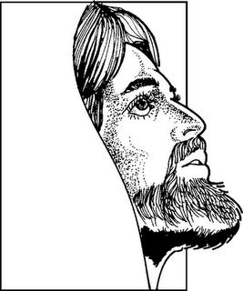

Station 2: Jesus is Arrested! The soldiers came and bound him in the darkness of the solitude night. Given away by a kiss, a kiss from one of his own, a trusted disciple, a trusted apostle, a trusted treasurer, given away by a kiss. The answer to Jesus’ “if” came in that. It could not be, whoever these soldiers represented, whatever authority they bore, had accused this alone one of crimes. They saw him as dangerous to what was and how it was. Yet, they also feared him for his hold over the people who bristled at their authority and the abuse of that authority. So in the darkness they came and bound him. Humanly speaking one might assume “he did something wrong!” And Jesus let the assumption remain. This too was part of God’s “Yet”. “Yet”-God gives us true life, Jesus alone for our sake. Thy will be done.
Station 3: Jesus is Tried! The Sanhedrin was the one to whom the soldiers brought the alone one, the arrested one, this Jesus. They were for most in that country the authority. They, as flawed as they were, they were the authority authorized by God. “¹⁰ But you shall make a register of Aaron and his descendants; it is they who shall attend to the priesthood, and any outsider who comes near shall be put to death.” Numbers 3:10. God’s Word spoken through Moses, this was the law. “If” they spoke... They had the right to question, especially if reports were true. So they questioned: “If you are the Messiah, tell us.” There is that word again “If”. Jesus, alone, arrested, tried repeats “If”...”What is God’s will?” “What if...? “If I tell you, you will not believe; and if I question you, you will not answer. Yet, from now on the Son of Man will be seated at the right hand of the power of God.” In the ears of the authorities that was enough. Their “If” was answered. Their judgment was justified, not only was he saying he was the Messiah, but the very power of God. Blasphemy! How dare he? The nerve of Jesus, bound before them, “Yet” was enough. He deserved death. “What further testimony do we need? We have heard it ourselves from his own lips!”
And Jesus alone let the verdict stand, in it was God’s “Yet!” “Yet”-God gives us true life, Jesus alone for our sake. Thy will be done.
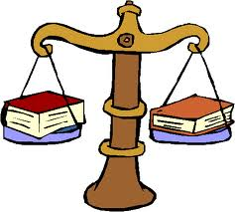

Station 4: Tried! Again Tried! Jesus alone tried by the power behind these priests and elders, the real power, the power of life and death. Pilate was brought in the frenzy of it all to his judgment seat! This one, Jesus alone, arrested, tried, and convicted stood before him, the power, the authority...the representative of the world’s great power and authority the Emperor and his Empire! They, this backward people, could make decisions, but what of them? He was the final “Yes!” or the final “No!” “If” he is accused, “if” he has been arrested, “if” he has been convicted, then... ? “Yet” let’s hear this out. “What has he done?”
The accusers declare: “We found this man perverting our nation, forbidding us to pay taxes to the emperor, and that he himself I the Messiah, a king.”
“If” this is true, he is guilty. Perverting a nation?, what peasant leader does not? Forbidding us to pay taxes? What foreign land wants to pay tribute and taxes to the Emperor? But an anointed king, the Messiah or Christ? If this is true, the judgment of death is just. The Emperor alone makes kings and destroys kings, the Emperor alone makes Sanhedrins and destroys them, the Emperor alone makes governors and destroys them. The Emperor alone! “If”....”Yet”...he was from Galilee Pilate hears, so send him to Herod, that is the Emperor’s authority there. Yet, this one, this Herod’s son, sent him back.
This trial of Jesus alone brought friendship to us, this may be helpful if this place becomes unruly, but no answer to the question of Jesus’ guilt or innocence. Let me release him! “You brought me this man as one who was perverting the people; and here I have examined him in your presence and have not found this man guilty of any of your charges against him. Neither has Herod, for he sent him back to us. Indeed, he has done nothing to deserve death. I will therefore have him flogged and release him.”
NO! is the response, Release the other Jesus, Jesus Barabbas!
“Crucify Jesus, Crucify him!”
“Why, what evil has he done?”
“Crucify him!”
“Yet”:
“..So Pilate gave his verdict that their demand should be granted!”
And again, Jesus alone let the verdict stand! In it was God’s “Yet!” “Yet”-God gives us true life, Jesus alone for our sake. Thy will be done.
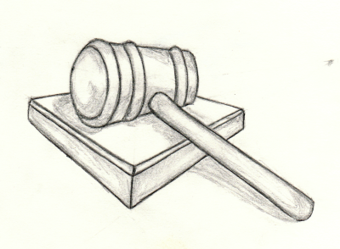
Station 5: Pilate condemns Jesus to Die! How can the God of life allow this death to happen? How can God’s “Yet” include this heinous act, not just any death, but a Roman death, Crucifixion? Our “Ifs” come into our mind at this. Our “Ifs” want to replace this death with something glorious, victorious, non-threatening. But our “ifs” cannot fathom God’s “yet”.
Pilate released their Barabbas, found guilty of murder, deserving of death, but desired by the people, the other Jesus who acted and fought against these overlords, The Romans. Give them what they want; we can deal with him perhaps later. What is one more dead Jewish upstart? There had been so many over the years, who could keep track. “I will wash my hands of the whole affair; it will be on them, not me!” Death, Cruel Death, Slow Death, Crucifixion.
And Jesus alone, condemned to die, sees the drama of it all, sees the tragedy of it all, the comedy of it all! “IF” only! In it was God’s “Yet!”
“Yet”-God gives us true life, Jesus alone for our sake. Thy will be done.

Station 6: Jesus wears the Crown of Thorns! A crown showed the world the glory and power and the favor of the gods upon the wearer. From Ancient Egypt and Babylonia to now Rome, a crown even of laurel meant something good. How could something so universal be turned to an item of scorn? “If” they knew.. Thorns, turning a good to a bad; Thorns, turning accolades into mockery; Thorns, pressed into his head! Calling him the Christ, anointed with kingly oils...let him sweat, let him be anointed in his own blood.
And Jesus alone, the Christ, let their mocked reverence, their mocked crowning, and their mocked anointing stand! In it was God’s “Yet!”
“Yet”-God gives us true life, Jesus alone for our sake. Thy will be done.
Station 7: Jesus Carries the Cross! The cross was the final act in a cruel day of bearing so much for Jesus alone! There was the physical: beating and whipping, the thorns...but then there was the emotional: betrayal, mocking, lying. What could this all mean? And finally the cross-beam carried to a place outside of the city, a hill of shame. After everything to carry that as well, through the streets of this city that meant so much to him as a Jew, as a Rabbi, as the Son of God. What could this mean? The load or burden meant more than the physical beating and torture, more than the emotional humiliation...this beam, this heavy beam carried through the streets of the most holy city in the world to a place outside was the world’s answer to God’s “If”...
” ³ If you follow my statutes and keep my commandments and observe them faithfully, ... ¹¹ I will place my dwelling in your midst, and I shall not abhor you. ¹² And I will walk among you, and will be your God, and you shall be my people. ¹³ I am the Lord your God who brought you out of the land of Egypt, to be their slaves no more; I have broken the bars of your yoke and made you walk erect.” Leviticus 23:3, 11-13.
God promised to break the bars of the yoke, to lift up a people bent over by slavery, physical slavery in Egypt and later emotional slavery caused by sin. They had called out in their affliction and God heard them and longed to lift them up. Yet, they returned to the former ways, clamoring for flesh pots in Egypt, or turning against their neighbors to burden them down with judgment and scorn for the smallest infraction.
This bearing the cross through Jerusalem, the City of Peace, by the Prince of Peace, revealed the weight that our God was to go to turn our “Yet” of sin and waywardness and slavery into his “Yet” of forgiveness, love, mercy.
And Jesus alone, carries this burden, bears the yoke to a hill of scorn and hate. “IF” only! In it was God’s “Yet!” “Yet”-God gives us true life, Jesus alone for our sake. Thy will be done
.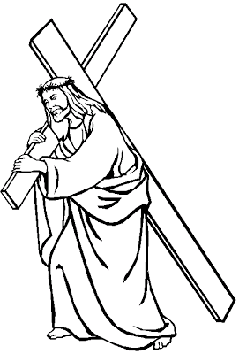
Station 8: Simon of Cyrene helps carry the cross. Physically, Jesus was still only human, alone in the verdict, alone in beatings...exhausted, spent. Roman Duty meant that the criminal be taken as quickly as possible to the place of execution, especially as the week drew to the Jewish Sabbath and the Jewish Passover. The Roman soldiers knew how little could set off the crowd. They could whip this Jesus more, try to compel him to hurry, but the look was obvious, Jesus was done. It was not even considered to help him themselves. It was far below any Roman to carry this cross beam reserved for the worst and the non-citizen. But by the clothes of that one, yes, that one from the area of North Africa, that different one.
And Jesus alone, left alone by his closest one, his disciples and his apostles, those who had said “You are the Messiah!”, those who said “To whom shall we go, you have the words of eternal life!” Where were they to help? Alone except for a stranger forced to help. “If” perhaps had I taught better, “If” perhaps had I demanded more, “If” they had seen more truly the power of God through me. “If”...
“Yet” in God’s plan he reaches not only to the known, the chosen, but the stranger even the ends of the earth, to Cyrene and the Gates of Hercules-the Strait of Gibraltar. In it was God’s “Yet!”
“Yet”-God gives us true life, Jesus alone for our sake. Thy will be done.
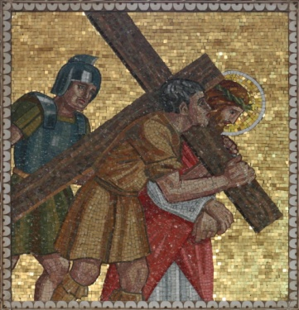

Station 9: Jesus Speaks to the Women: Wailing at the sight, those condemned, pitiful yes, but this one who came in triumph. This one whom we threw down our cloaks, whom we proclaimed Hosanna, whom we spread branches before, this one was our hope. This one on a colt, would break the oppressor’s rod over us and give us freedom, make us great, lift us up. All is lost as the oppressor declares in the cross, He is dead!, and you are lost.
Finally Jesus alone speaks “Daughters of Jerusalem, do not weep for me, but weep for yourselves and for your children. For the days are surely coming when they will say: “Blessed are the barren, and the wombs that never bore, and breasts that never nursed. Then they will begin to say to the mountains, ‘Fall on us’; and to the hills, ‘Cover us.’ For if they do this when the wood is green, what will happen when it is dry?”
This judgment by men upon the Son of Man seems final. “Yet” God knows man, God knows man’s heart, they will do worse. Even if one is raised from the dead they will not believe, cannot believe because their minds are dim with their own progress and power. “Yet” God works even in the worst. God works even through the worst. Jesus alone sees clearly this “Yet” of God.
In it was God’s “Yet!” “Yet”-God gives us true life, Jesus alone for our sake. Thy will be done.
Station 10: Jesus Nailed to the Cross. Not just a way to affix a person to wood, but the most painful way. Not just a way to kill a criminal, but a slow way, no mercy! This was a message to all those who dared to question authority, to question the Emperor. “IF” means death.
“Yet” in this is God’s purpose. Reveal the worst, declare the worst, be the worst. “Yet” God would do best for a sinful people. In it was God’s “Yet!”
“Yet”-God gives us true life, Jesus alone for our sake. Thy will be done.

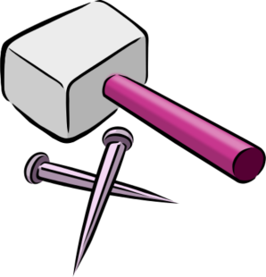
Station 11: Criminals Speak to Jesus. They had been sentenced justly. They knew it. But one could not resist joining the throng of leaders and people shaking their fists, mocking this Jesus. The other in a moment of clarity called the offense what it was: “Do you not fear God, since you are under the same sentence of condemnation? And we indeed have been condemned justly, for we are getting what we deserve for our deeds, but this man has done nothing wrong.” Deriding from one...but the other turning to Jesus perhaps thought “If...if I can speak to this innocent one, if...?” “Jesus, remember me when you come into your kingdom.”
Jesus replied, “Truly I tell you, today you will be with me in Paradise.”
Our “ifs” are revealed in the moments of even just condemnation to be where God steps in with his word, not a word for the way off future where it seems all “ifs” point, but to right now. “Today” Jesus said, “you will be with me in Paradise.”
In it was God’s “Yet!” “Yet”-God gives us bliss even through the judgment and condemnation that are sins bring. God gives us his “Yet” in Jesus alone for our sake. Thy will be done.
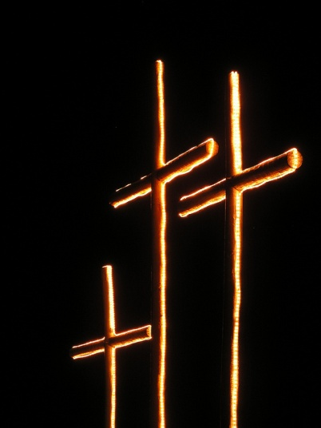

Station 12: Jesus Cares for His Mother. Mary, who bore him into a world of questions, into a world of proper order, who bore him even before she was wed; Mary, who felt the embrace of an old barren cousin, fat with child, who despite the rumors was declared blessed among women; Mary, who saw shepherds declare and rejoice, who saw wise men bow down, who fled a fearful King, who heard an old man weep for joy “My own eyes have seen your salvation!” and an old prophetess declare God’s praise at the sight of the child, this was God’s redemption. Mary who treasured so much in her heart but knew that even in the joy this child, her first son, would bring pain as he was rejected by the world. She followed him to this place of the skull, this place of death. He saw his mother and as not only the Son of God living into God’s “Yet” cared for her as the firstborn. To his disciple, the beloved one, “Behold, your mother!” and to Mary, his mother, “Behold, your son!” the earthly business was over, finished done. “Ifs” for him were at an end now only was God’s final “Yet”.
We hear that Christ emptied himself of his divinity to live among us, as such Christ alone lived fully a human life with all that means for the Son of God.
In it was God’s “Yet!” God’s Son, yet, born of Mary.
“³⁴ Then Simeon^{[a]} blessed them and said to his mother Mary, “This child is destined for the falling and the rising of many in Israel, and to be a sign that will be opposed ³⁵ so that the inner thoughts of many will be revealed—and a sword will pierce your own soul too.” Luke 2:34-35 NRSV
There is pain in this story, “yet” through it God gives us bliss, through brokenness of body, brokenness of spirit, brokenness of relationships with those we love, God gives us his “Yet” in Jesus alone for our sake. Thy will be done.

Station 13 Jesus Dies on the Cross. The height of the day was there, the sixth hour, what we call noon. The brightest time of the day, but all turned dark. “It was now about noon, and darkness came over the whole land until three in the afternoon, while the Sun’s light failed...” This light set in the heavens at the beginning of time to rule over the day...this light that God saw as good on the fourth day of creation. This the mightiest of lights for all creation, warmth and growth and teller of time, this light failed. How could that be, it was sure, it was given, it was forever, “yet” it failed. “If” it failed, the world was gone. This “if” only had one answer.
“MY GOD! MY GOD! Why have you forsaken me?”
“...and the curtain of the temple was torn in two.” This curtain, protective of the people, holding in the very presence of God in the inner, holiest, part of the temple, a place no one, no one except the High Priest went but once a year; protection gone, wrath, judgment, death unleashed at a people yet to be atoned for. The ripping of cloth though was also a sign of grief, lament, even anguish: Darkness, creation on hold, the presence of God seen no cloud or cloth to cover, but God’s Son, on the cross, rejected; But God’s Son, struggling to find a breath, a breath of life. “Father, into your hands I commend my spirit.” And he breathed his last. God’s Son dead.
There seems to be no “if” in this, there seems to be no “yet” in this. It is so final this death, this death for Jesus alone, but all creation too. The Sun failed, the Curtain torn. God weeps. Thy will be done.
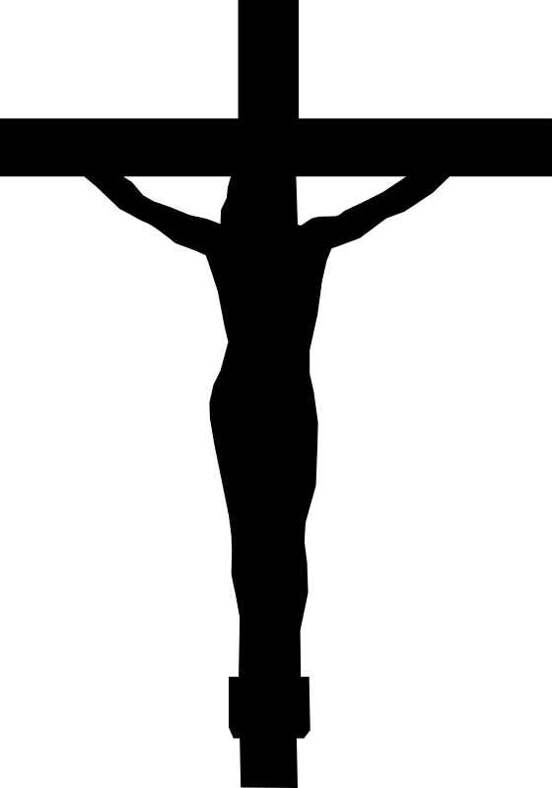
Station 14 Jesus is Laid in the Tomb. The week was coming to an end, Sabbath was upon them. Haste, for those that still cared haste; get the bodies away and in the ground before the sun sets. Joseph of Arimathea, a leader and a member of the Sanhedrin, but a follower in secret of this Jesus, asked for the body of Jesus. He took it down, wrapped it in linen and Jesus alone was laid in a new tomb. A body that would rot, would return to the dust, a body whose bones would be backed after a year or so into a stone box. It was custom, it was right, it was over. Death-Burial. A stone was placed over the tomb, that was custom too. “If” though those of importance thought, if they try and trick us, something must be done: A stone with a seal and a guard.
And “Yet”....? Thy will be done.

Amen.

